Simulating larval chemotaxis
Alex Davies – University of Edinburgh
s0784670@sms.ed.ac.uk

This document is somewhat out of date, but gives some idea of how larvae are controlled in the simulation.

Aims
There are two main reasons for the development of the simulator discussed in this document:
- Test the extent to which larval chemotactic behaviour can be explained with a control scheme in which transitions between two simple behaviours are based on a short history of a single perceptual value.
If real larval behaviour cannot be matched with our simulation, the discrepancies may suggest what is missing from the current description, e.g. are curved paths, or a memory of previous decisions needed?
- Provide a platform for future work investigating larval odour learning.
Having an arena in which a simulated larva can move around in an odour gradient will allow more realistic simulation of the pairing of cues, and help develop our understanding of the relationship between learning and behaviour.

Description of simulator

General description
We simulate a single larva crawling within a 2-dimensional odour gradient. The larva is made up of two sections, a 'head' section and a 'body' section.

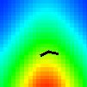Figure 1: Simulated larva. (Heat map indicates odour value.)

The larva has two distinct behaviours, forward crawling and head casting.
- During forward crawling the head section moves in the direction it is currently oriented, at a constant speed, 'pulling' the body section with it. This means that the 'body' section will rotate to align with the 'head' section as the larva moves.
- During head casting, the head section rotates from side to side relative to the body section. Upon reaching the limit of rotation in one direction, rotation in the opposite direction begins immediately. Head casting may terminate with the head section oriented differently to the body section, resulting in the larva moving off in a new direction.
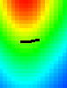  Figure 2: Forward crawling | 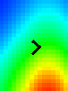  Figure 3: Head casting

The larva's trajectory over the course of the simulation depends primarily on how the it switches between these behaviours. The behaviour switching scheme is described in Section 2.3.

Odour and perception
The intensity of the odour at any location in the simulation given by a single number. In current simulations we have used a distribution of odour which is the sum of two 2D guassians, to give a similar distribution to that seen in (Gomez-Marin, Stephens, & Louis, 2011)⁠. This could easily be changed to investigate different situations.
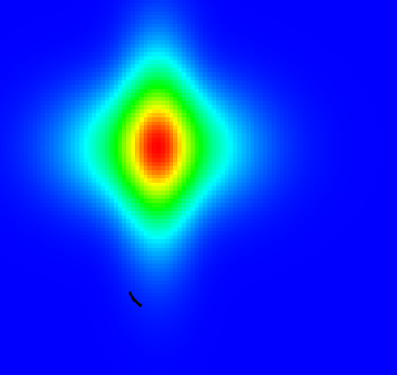Figure 4: Odour distribution

We use the odour value at the tip of the simulated larva's head section, , to define a measure of the larva's 'perception', . Following (Gomez-Marin et al., 2011)⁠, this is given by .
This is the only information the simulated larva has about the environment, and all decisions are made based on a limited history of this value.

Behavioural control
Control of the larva's behaviour can be most easily shown with a state transition diagram:
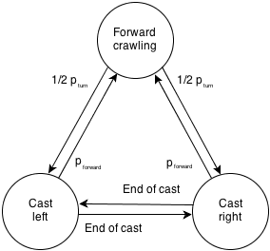Figure 5: State transitions for simulated larva behaviour
The larva's starting state is forward crawling. With a probability based on perception values, it can transition into head casting left or right. When a left or right head cast reaches its maximum rotation, the state switches to a head cast in the opposite direction. From head casting in either direction, the larva can transition back to forward crawling, again based on perception values.
We suspect that the larva could be performing chemotaxis with a combination of two behavioural controls:
- Initiate head casts upon detecting a gradual decrease in perception value while moving forwards
- Terminate head casting on detecting a sharp increase in perception when head casting
To encode these ideas into our simulation, we calculate two probabilities: , the probability of switching from forward crawling into head casting at time , and , the probability of switching from head casting to forward crawling at time . These are calculated as a base probability, , plus the convolution of some kernel, , with the perceptual history, .

We can then define kernels to translate the appropriate perceptual events into transition probabilities. For example, we wish a steady decrease in the perception value to lead to a high probability of transitioning from forward crawling to head casting, so we set to be a gradual slope with negative gradient.

Parameters
There are a number of important parameters which need to be set for this model.
: the maximum angle of head casts
: base probability of initiating head casts
: length of perception history used for determining turn initiation probability
: base probability of initiating forward motion
: length of perception history used for determining forward crawling probability

Other than these parameters, we also need to determine the kernel used for calculating both transition probabilities. We have currently only considered linear kernels, which reduces the number of parameters for each kernel to 2:
: start value of the turn kernel
: end value of the turn kernel
: start value of the forward kernel
: end value of the forward kernel

Matching larval behaviour
In order to determine whether the simulation exhibits similar behaviour to real larvae, we compare behavioural statistics taken from (Gomez-Marin et al., 2011)⁠ to those of our simulated larva. As far as possible, these statistics are computed in the same way for the simulation as they were for real larvae.
The behavioural statistics vary with the choice of the parameters described above. The values used for the results below were found by manual adjustment of parameters, and are given in section 4.1. While there are too many parameters to make a complete search of the space, some form of optimisation could be used to find better fits to larval data – we may look at this in the future. For the time being, the results below at least give an indication that some similarity to real larval behaviour can be achieved.
(Currently, these statistics are drawn from a single run (~10 minutes simulated time) of the simulator. I'm working on putting things together to collate data from multiple runs, which should give better results, and allow calculation of variances etc.)

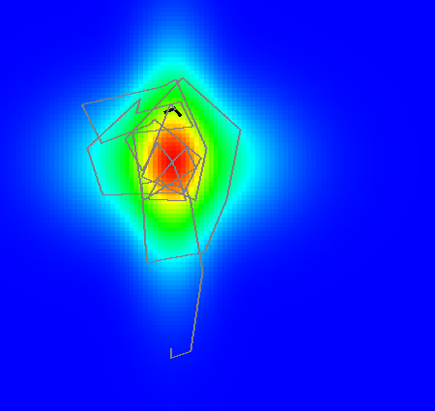Figure 6: Path of a simulated larva

Figure 6 shows a typical simulated path. The simulated larva is able to navigate towards and stay in the region of the odour source.

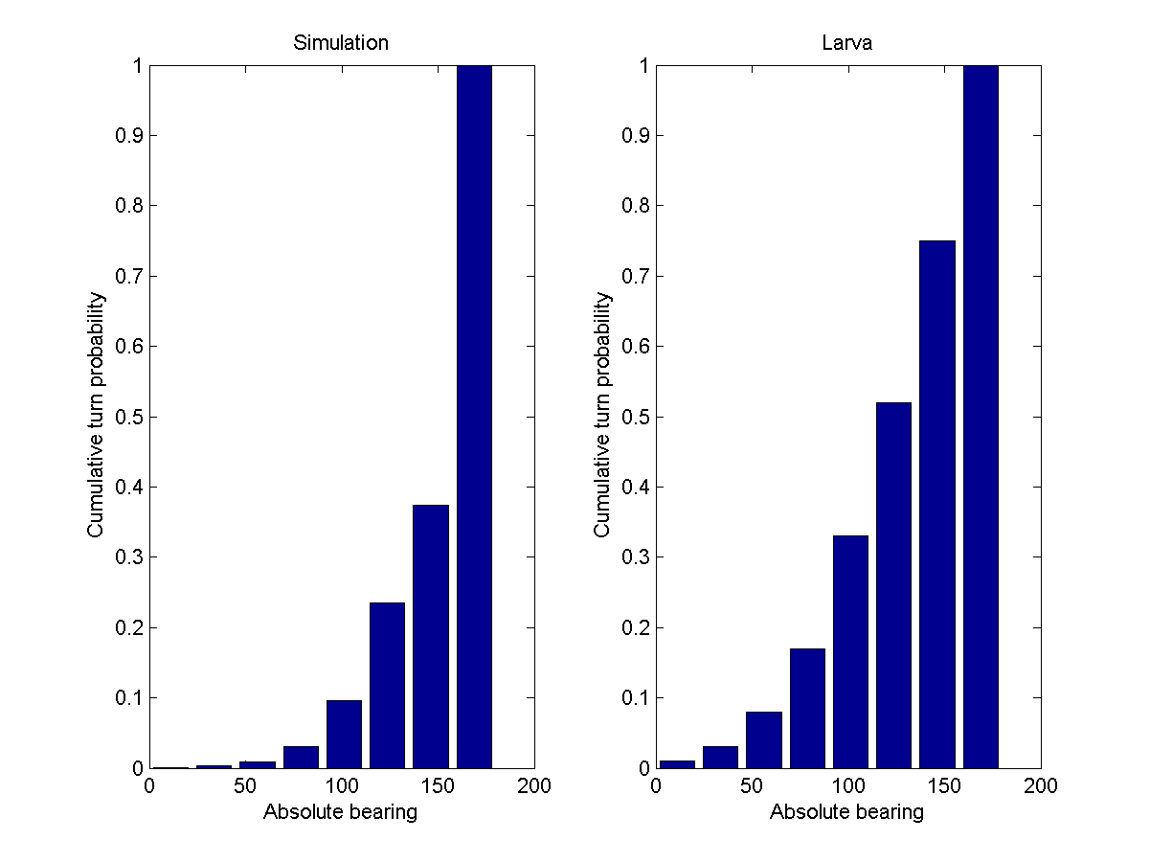Figure 7: Turn probability plotted against bearing for real and simulated larva
Figure 7 shows turn probability against bearing. 'Bearing' in this case is relative to the local direction of the odour gradient, i.e. bearing 0 means towards the odour, and bearing 180 means away from the odour. The simulation captures the exponential shape of the distribution, although shows fewer turns at lower bearings (i.e. fewer turns when moving almost directly towards the odour source).

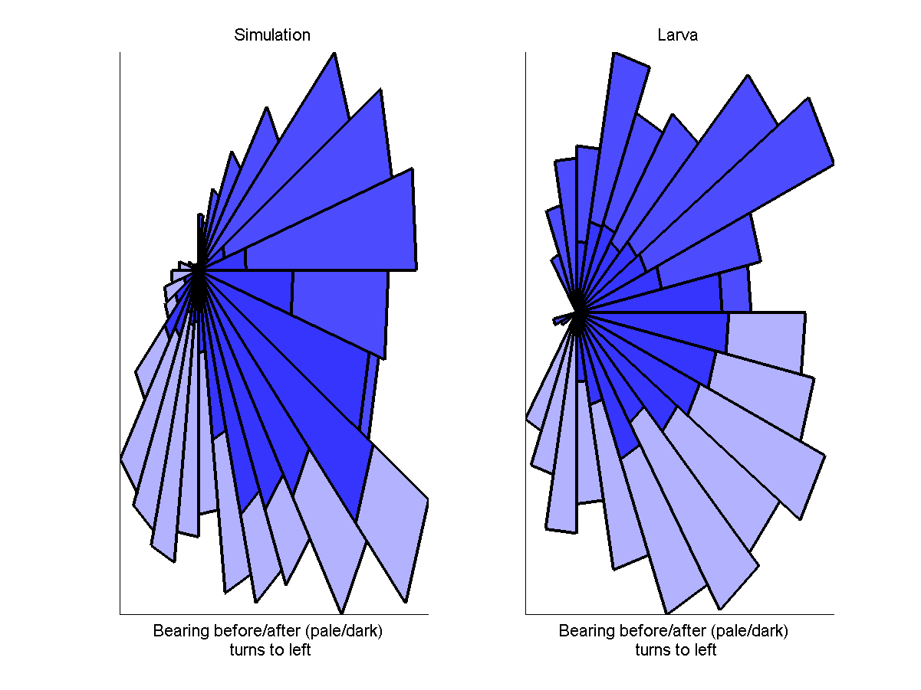
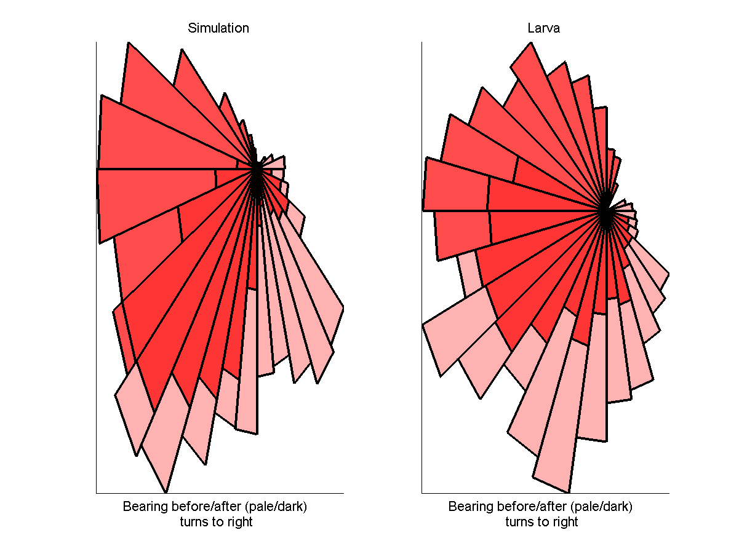Figure 8: Distribution of bearings before / after turns
Figure 8 shows distributions of bearings before and after turns. The simulation captures the general property of mostly turning to the 'correct' side, i.e. the side which is closer to the direction of the odour gradient, and also in generally undershooting turns.

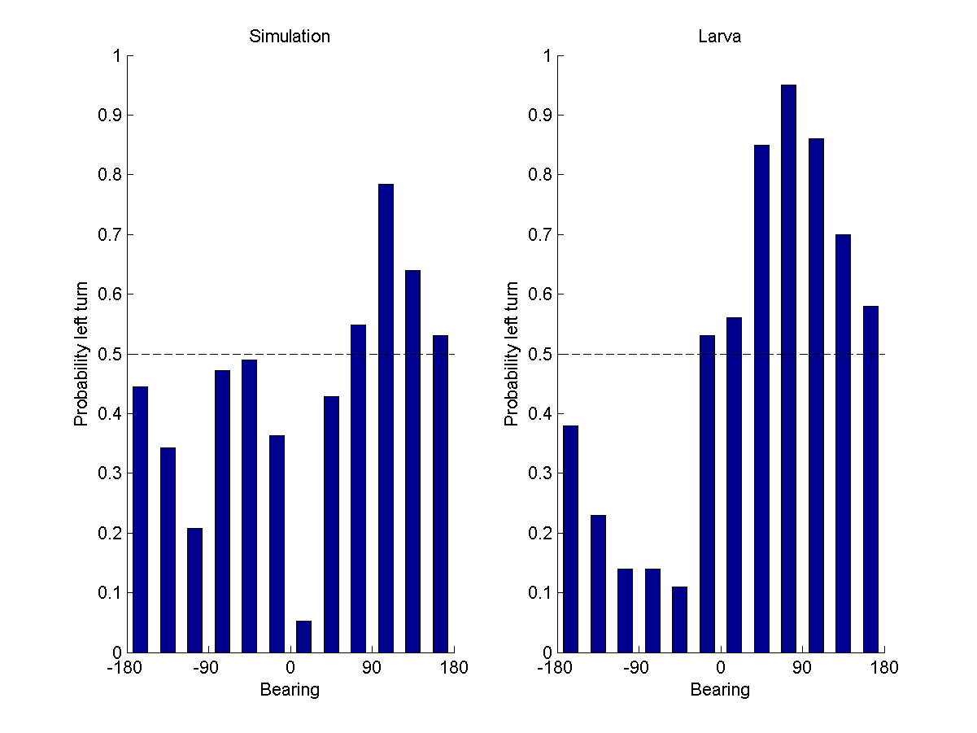Figure 9: Probability of left turn plotted against bearing
Figure 9 shows probabilites of turning left from different bearings. Despite some obvious discrepancies, some of the sinusoidal shape can be seen in the simulation data.
(While not shown on the graph here, it's worth noting that for the simulation there are very few samples for the turns near bearing 0 – corresponding to the lack of turns at low bearings seen in Figure 7. I'm working on gathering simulation data better, i.e. with multiple runs, which might smooth this out somewhat.)
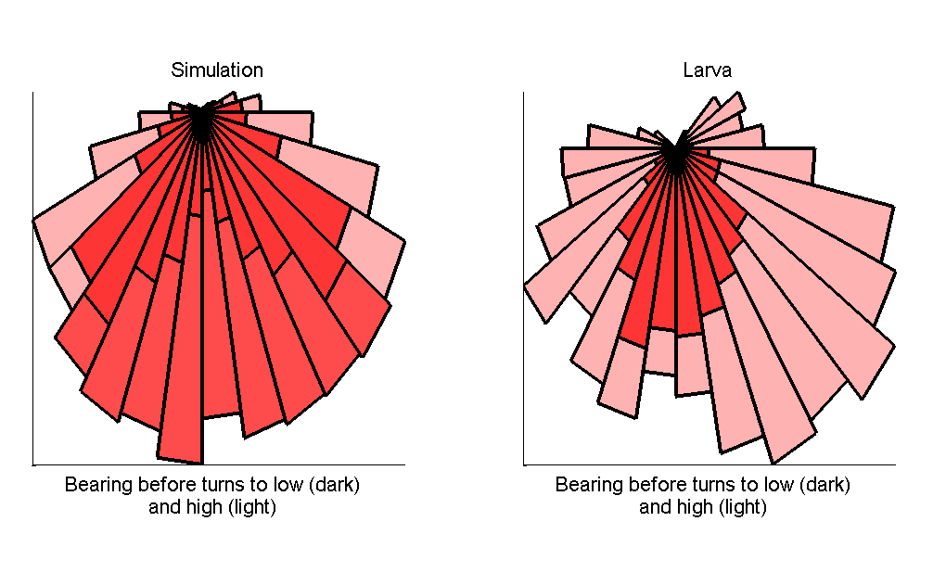Figure 10: Bearings before turns to low and high
Figure 10 shows bearing before turns to low and turns to high.
(Of the behavioural statistics I've looked at, this is the biggest discrepancy between my simulation and real larva. I'm still looking into why this is, and whether it can be improved!)

Parameters
The parameters used to obtain the above results were as follows.
:

: 0.0
: 10s
: 4
: -4

: 0
: 2
: 0
: 3

Bibliography
Gomez-Marin, A., Stephens, G. J., & Louis, M. (2011). Active sampling and decision making in Drosophila chemotaxis. Nature communications, 2, 441. doi:10.1038/ncomms1455

